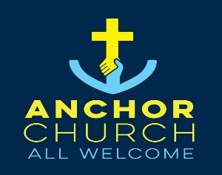
Anchor Church Leeds
Currently based in North and East Leeds following Jesus, building community and living with hope

Anchor Church Leeds is a Baptist Church committed to being present, prayerful and practical in North and East Leeds and drawing from a wider area. We believe God is in the city – among its people, streets, stories and struggles – and we are called to join it.
As followers of Jesus, we are shaped by His example: welcoming the outsider, standing with the overlooked and offering hope where it’s needed to most.
We are a growing dispersed and diverse family of faith who gather to worship, scatter to serve and walk alongside our neighbours in everyday life. Whether in homes, community spaces, cafes or parks, we seek to love out the Gospel in creative, inclusive and authentic ways.
Anchor Church is a group of people who found ourselves together in a new way through unexpected and sometimes challenging circumstances and people who have joined us from the local area. We have prayed and nurtured one another through this and have become Anchor Church Leeds.

Who is Anchor Church Leeds?
Anchor Church is made up of 30 committed members and at present our church is based in the expanding and developing area of East Leeds. We span the complete age range from babies to the elderly and have a mix of ethnicities within our church family. Anchor Church works hard to include anyone as they come to us, and all are welcome regardless of background, lifestyle or circumstance.
We have a strong leadership team of 5 members who prayerfully lead the church as we move forward to build and develop as a worshipping community. At present, Anchor church meets on 3/4 Sundays a month at Chapel FM Community Arts centre in area of Seacroft. The remaining Sunday we encourage our members to meet in their Hubs or worship in their local community. Our services are very relaxed and are a mixture of sung worship, prayer, teaching and social gathering for one another.

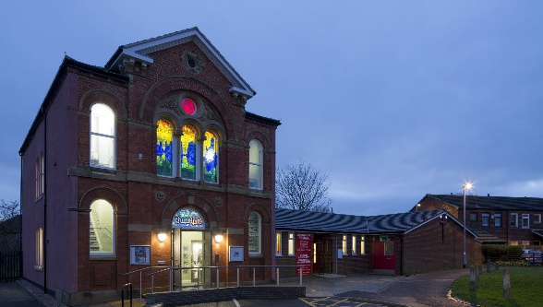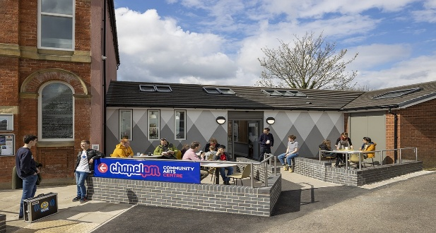
Chapel FM Arts Centre, Seacroft
Where is Anchor Church Leeds?
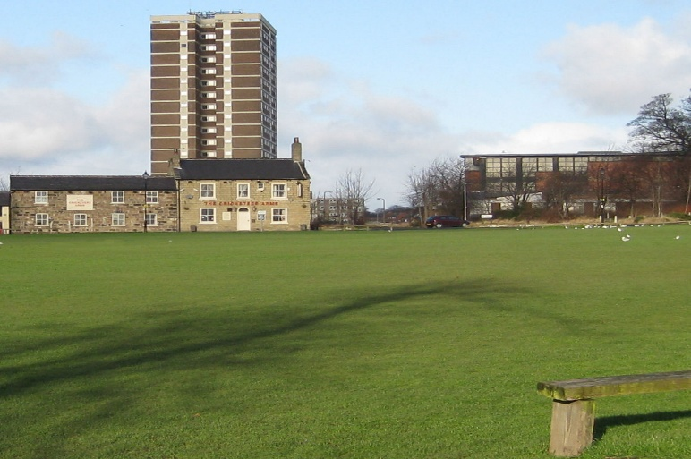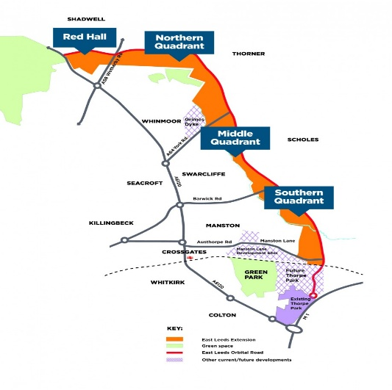
Seacroft Green Planned new development areas
East Leeds as an area is growing significantly with many new estates and homes being built in the vicinity – a brand new mission field. However, there is also significant opportunity for mission in the local area, ie in the immediate vicinity of Chapel FM Arts Centre – an area with levels of high deprivation and unemployment. There are local churches in the community working and running a Food Bank, which Anchor Church supports. The area also has a hotel used to house refugees and again alongside Chapel FM, Anchor has supported work with this particular focus.
Anchor Church wants to be a visible presence in North and East Leeds and the surrounding area. We are Baptist in identity – valuing community, discernment, shared leadership and believer’s baptism – and we hold Jesus at the centre of all we do. We affirm that the Good News of Christ Jesus is for everyone.
What is Anchor Church Leeds?
Anchor Church is a community of faith, anchored in the truths of the Gospel and passionately committed We want to share God’s love through hospitality and relationship as well as build new and strengthen existing communities of faith and discipleship within our church. Our vision is to be a beacon of light, shining brightly in our community, offering refuge, restoration and support to all who seek it. We want to be a church which actively engages with our neighbours partnering local organisations and communities. We aim to be a church where every individual regardless of background or circumstance finds belonging, purpose and hope in an inclusive and loving community that reflects the grace and mercy of Christ.
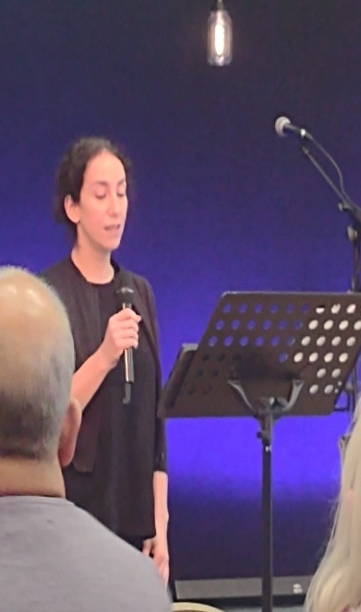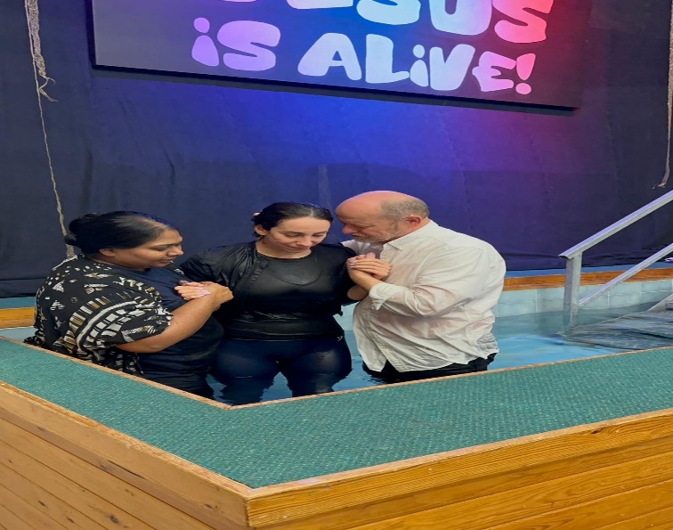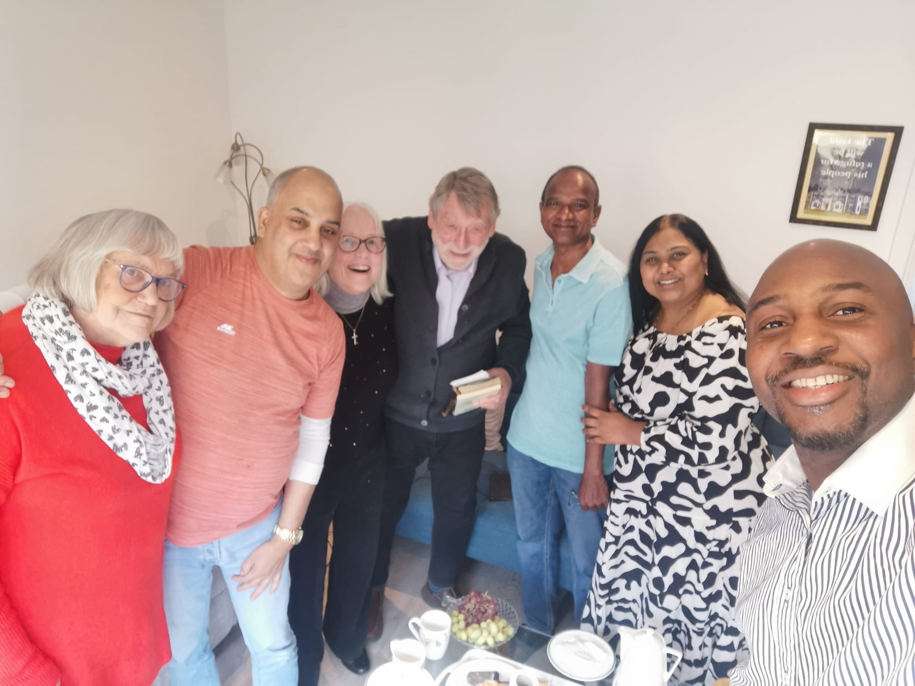

Our search for a minister
Anchor Church is looking for a part time minister for initially 3 years who will lead and support Anchor Church Leeds in its mission to connect with those outside traditional church structures, while also strengthening existing hubs or small groups of community and discipleship. This role combines pioneering outreach with pastoral care and leadership development, helping existing groups flourish and new ones emerge.
Our essential requirements are that our minister is vibrant and rooted in the Christian faith with a clear or developing call to evangelism, discipleship and pastoral ministry. We would want them to have strong relational and communication skills with a deep love for all people. It would be important that they can work independently, as well as initiate and sustain new projects or relationships. Our minister must have a commitment to Baptist principles, including the importance of community discernment, shared leadership and mission.
An accredited or recognised Baptist minister or someone on that pathway ie. a minister in training is desirable but not essential as is a theological or ministry formation training whether formal or informal. It would also be desirable that our minister would have had some experience of community building, discipleship and pastoral care whether as part of training or personal experience.

Key Responsibilities
- Developing Mission and Outreach
Engage with people and communities not currently reached by the church through outreach and evangelism
Develop new expressions of church
Build trust and relationships
Explore fresh opportunities for witness, evangelism and hospitality in everyday life.

- Strengthening Existing Church Hubs
Support and nurture Anchor Church’s small group gatherings
Encourage growth in depth and breadth – strengthening discipleship, inclusion, leadership and outreach.
- Pastoral support
Offer relational, informal pastoral care to individuals and groups connected to the church alongside pastoral work already happening within the church
Help others grow in faith, resilience and community through prayer, mentoring and presence
Support people through life transitions, struggles and spiritual exploration
Collaborate with others on the leadership team to ensure a sustainable and shared pastoral approach
- Prayerful Discernment and Reflection
Help Anchor Church discern where God is leading and how to respond faithfully
Cultivate personal and communal rhythms of prayer and spiritual listening
- Leadership Development
Encourage participation and shared leadership within a congregational/ Baptist model
Work closely with the church leadership team and participate in team meetings and planning
Help to develop the church’ social media in order to make the church known to a wider audience.

What can Anchor church offer a new minister?
Anchor Church is a very caring community who is longing for someone to bring us on and move us as a church into the next phase of our development. We are open, friendly and supportive with physical and practical support, but also prayer and spiritual support. The church has the funding for a part time role of 3 days a week on the standard BU stipend pro rata for 3 years at present. The church does not have a manse but accommodation would be provided or an allowance depending on the minister’s personal circumstances. Although not essential, we would encourage a minister to live in the local area of North or East Leeds.
We can ensure that any minister has strong supervision from a senior and experienced leader as well as an external mentor. Anchor will ensure that their minister receives training opportunities and support from networks such as Baptist Together and other local Leeds groups. The leadership team meets regularly and is open to new ideas and developments for the church. We are enthusiastic and willing to see how God will lead us and work in our church, the local and wider community and in our every day lives.



