INFORMATION AND APPLICATION PACK 2025

**MUSICAL WORSHIP LEADER**

FOR HOLY TRINITY CHURCH IN BEMBRIDGE

**Introduction and Background to the Role**

Holy Trinity Church is a mid-sized Anglican Church set in the beautiful village of Bembridge on the stunning Isle of Wight. Our church has a usual Sunday Attendance of around 120 adults, although at Easter and Christmas our strong community links swell our congregation to over 350. This close connection with our community, represents an exciting and on-going missional opportunity.

We long to be a deeper, more vibrant and growing community in Jesus. Since emerging from COVID in 2021 more than 100 people have joined our village church family as we have sought to be disciples of Jesus who whole-heartedly love God, our world and each other. We want to be a church that welcomes people – all people. This means we try to be as broad as we can in terms of:

* background & age;
* focus, eg. preaching, worship, mission, service and social justice; and
* worship preferences (ranging from traditional to contemporary).

We are broad in terms of our mission and emphasis. We are evangelical in terms of our values. What this means is that the Clergy, the Leadership and our beliefs are evangelical.

We are seeking a passionate and Spirit-led person to join us in making musical worship a dynamic and inspiring cornerstone of our ministry. We believe that through musical worship, the Holy Spirit nurtures and deepens our faith, and draws us closer to God, and to one another. Our prayer is for someone with the vision and heart to lead children, young people, and adults into authentic, heartfelt, and transformational worship.

This role is about more than leading songs - it’s about cultivating a worshipping culture that resonates across generations and connects with the everyday lives of those in our community. If you sense God’s call to use your gifts and passion to

* build on the missional opportunities already present in our village and local school,
* help establish a new worshipping community, and
* breathe fresh life into our warm, outward-looking and faithful congregation,

then we would love to hear from you.

We hope that this document will provide you with the information you need about our church and the role. If you have any questions, please do contact me using the details at the end of this document.

With love



Ven. Steve Daughtery.



**1. The Role of Musical Worship Leader**

We are looking for a visionary leader who is passionate about musical worship and who will help us offer to God worship that inspires and builds our faith. We are looking for someone who is Jesus-centred and Kingdom Seeking and who is able to develop missional opportunities within our local Church of England School, our village, and church to create for us a truly multi-generational worshipping community.

Our church is in the ‘foot-hills’ of inspirational musical worship. Our 10:30am Sunday service has a blended musical balance of hymns and songs. We have an organ and a small choir that leads our hymns, and a small music group that leads our songs. The traditional and contemporary elements are balanced, integrated and work well together to serve our mission. We have just launched a new worshipping community in our primary school that combines children; families; teachers; and church.

We pray that over the next three years, we will see the musical worship leader spearhead and encourage the development of:

* confident, heartfelt worship at our 10:30am Sunday service, enriched by inspirational music from the choir, music group, and organ;
* a thriving After School Service that becomes a new worshipping community, supported by high-quality contemporary musical worship;
* a new, multi-generational Sunday afternoon service designed to engage new generations;
* musical outreach to the community.

**Key Responsibilities**

* Develop with the Vicar and PCC a whole-church strategy for musical worship.
* Pioneer the development of a contemporary worship service in the school and on a Sunday afternoon in church
* Manage the delivery of inspiring musical worship for our 10:30am service in both traditional and contemporary form.
* Build on our excellent relationship with the local CofE Primary School to enhance and deliver music for their corporate worship (Assemblies and Flourish Activities)
* Attract, lead, equip and encourage new musicians to lead our worship and help them integrate into our music ministry.
* lead our sound desk team to ensure that the music and visual production is of the highest standard. Ensure that we have the right equipment to support our mission.

We hope that the successful applicant will also develop the above proposed music ministry in ways that may be more specific to their skill profile to develop our outreach.

**Our Commitment to You**

We will encourage you to undertake your work in a way that helps you to grow personally towards maturity in Christ.

We will create a working agreement with you that will seek to provide you with the support you may need

We will assist you in developing your strengths and gifts in the context of our life and mission together.

We will offer you collaborative, affirming and encouraging leadership.

We will support you in prayer, as a partner alongside us in our ministry, as a friend and colleague.

**Remuneration**

The remuneration package will be in the region of £25,000-34,000pa pro-rata, depending on experience.

The role is currently scoped at being half-time for 19 hours a week. However, depending on your skills and vision we are open to considering a greater number of hours.

Pension provision (Nest) will be provided in the light of current legislation.

28 days of annual leave pro-rata, excluding bank holidays.

All authorised expenses will be fully reimbursed.

Relocation support available

**Note:**

It is a Genuine Occupational Requirement (GOR) that the post-holder is a Christian. The post-holder will be expected to share our core beliefs, join in the spiritual life of the church, commit to worship every week and work actively to support our overall mission and vision. Appointment is conditional on successfully undertaking an enhanced DBS check.

**2. Who are we looking for?**

**Personal Attributes**

* An embedded, committed and confident Christian faith
* Ability to sensitively embrace the culture and ethos of our church and the vision of the Diocese
* A team player
* Able to inspire, equip and lead others
* Ability to respect matters of confidentiality and sensitivity
* An appreciation of worship styles foreign to one's own musical 'home', and an ability to work with classical and contemporary (rhythm-based) musicians.
* A self-starter with the ability to manage own workload with minimal oversight.
* Ability to work well and relate to people of all ages, genders and backgrounds.

**Skills and Competencies**

* A willingness to treat Safeguarding as a priority infusing all activities
* A confident lead voice
* The ability to play a lead instrument (keyboard/guitar*/organ*)
* Capable of leading and inspiring a diverse range of musical teams.
* A developing sense of discernment and the Holy Spirit’s leading in corporate worship
* Ability to work with young people and children,
* Ability to read music notation
* Ability to arrange parts for orchestral instruments in the context of contemporary music *

\**Desirable.*

**Knowledge**

* Understanding of the priorities and forms of traditional and contemporary music.
* Good organisational and administrative skills including working knowledge of IT.
* A good knowledge of mainstream contemporary worship repertoire, with the desire to draw from a wide range of musical 'camps'*
* Basic knowledge of sound setups*.

\**Desirable.*

**3. About Bembridge**

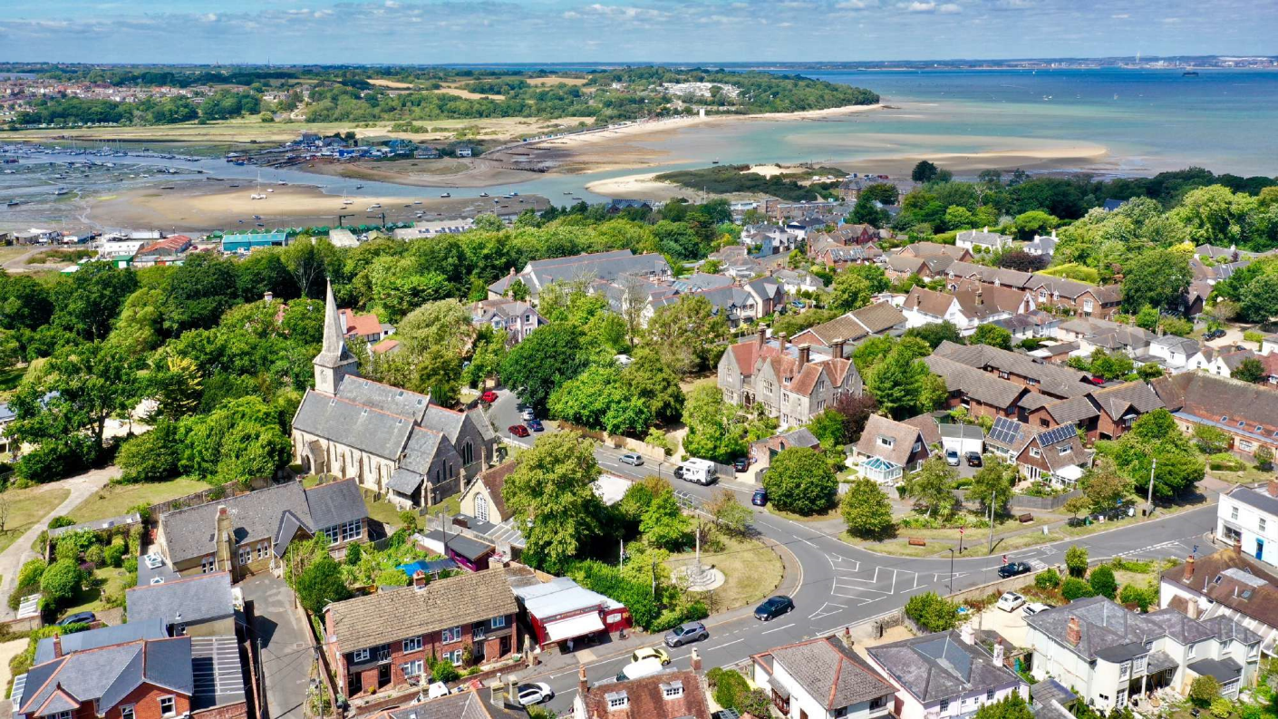

*“Four miles south of mainland Britain sits a diamond in the Solent, an island paradise blessed with golden beaches, verdant forests, ancient valleys and chalk white cliffs. It’s a land steeped in rich history, favoured by Kings and Queens and today the home of a thriving community proud of their heritage and tradition. Welcome to the Isle of Wight…”*

Alan Titchmarsh

Holy Trinity Church is found within the Parish of Bembridge. A seaside village, Bembridge was voted “Countryfile Village of the Year” in 2019. It is situated on the eastern tip on the Isle of Wight. This attractive and vibrant village is set adjoining the boundaries of an Area of Outstanding Natural Beauty, with a natural harbour, marshlands, chalk cliffs and sandy beaches.

The church dates from 1846 and stands in a churchyard, within a Conservation area, close to the village centre. A pathway from the south door leads to the church hall, known as the Cloisters. Holy Trinity is one of a trio of churches, the others being the Methodist Church, and the Roman Catholic church, St Michael and All Angels.

We are so blessed to have a fully equipped village with a butchers, a bakers, a farm shop and even some wonderful alternatives to candlestick makers. There is also a community run Library, a Heritage Centre and many popular take away food outlets, pubs, restaurants and cafes that cater for food lovers.

The village population of around 3.560, ebbs and flows with the seasonal influx of visitors to the Hotels, Holiday Parks and Campsites. Bembridge harbour has its own uniqueness. A tidal harbour, it provides safe waters for wild birds, with a community of houseboats dwellers, two popular Sailing Clubs, and many businesses linked to water-based activities. In the summer months the harbour is a kaleidoscope of colour as vessels of all shapes and sizes jostle for position. The fishing boats land their catch of crabs and lobsters and anglers wait hopefully for a tweak on their lines. The Marina and the long pontoon play host to many visiting yachts and motor cruisers and are alive in the evenings with events like Jazz on the Quay. The harbour can be crossed by water taxi during the summer months and by walking across the causeway to St Helen’s Duver.

Educationally, the Ofsted rated “Good” Church Of England Primary School and Windmills, the Pre School, provide care and education for children up to the age eleven in Bembridge. Secondary School education is provided by nine schools across the island. Outside of school, for the young there are packs of Rainbows and Brownies, Beavers and Cubs, troops of Scouts and Sea Cadets and thriving sports clubs.

The mission statement of Bembridge Church of England (Controlled) Primary School aligns with the church’s “Learning to love God, one another and ourselves”. We have an outstanding relationship with our school, strongly represented by our school Governors and an excellent team that leads Assemblies once a week. We have recently appointed a half-time schools (Flourish) worker who has created regular weekly Christian activities in school and begun a once a month all-age (children, parents, teachers and church) worship event.

The Bowls Club is a serious centre of competition, hosting many hotly contested tournaments during the summer months. The Bembridge Weeders, the Horticultural Society and Church Flowers Festival, keep all those with green fingers busy. Bembridge Singers, Bembridge Art Society, Pantomimes, Art Exhibitions, and the popular Street Fayre, are all community activities enjoyed across the generations.

The Lifeboat Station keeps the community safe on the water and together with the beautifully restored Windmill, run by the National Trust, are honey pots for visitors. An hourly bus and local taxi services connects the village to the rest of the island.

**4. Our Values**

**We have a high regard for the God’s Word**, the authority of the Bible. We believe that the Bible is God’s word to us. That it is true and without error in all that it means. We believe the Bible is completely trustworthy and contains everything that we need to

* understand who God is;
* understand how to be in relationship with Him; and
* know how to live in that relationship.

This means that the Bible’s teaching is at the very heart of everything that we do: our preaching, our worship, every group we run, our pastoral ministry and our mission. The Word of the Father makes sense of our world and sets our priorities and values.

**We are Jesus centred**. Jesus is God come to earth: he is the one for whom we exist; and he is the only way to know God personally. In an age where ‘God’ can mean almost anything, our faith is in the historic Jesus: God as Man.

Jesus came to do many things, but supremely, he came to die and rise again to conqueror death. On the cross a great exchange took place: Jesus took our sin, our guilt, our punishment and he gave us his forgiveness and life and hope. This is our incredibly important Good News!

So we believe we have an urgent public mission to serve the world by helping people know God through our words and actions that display God’s love.

**We believe God’s Spirit changes us** and that this change is crucial. We believe Christian faith is both transparently public and deeply personal. His Spirit brings us new birth, his presence changes us, he unites us into a new community that is warm and welcoming, that reflects the forgiveness of God and that desires to see each other flourish.

These are the beliefs that drive everything that we do. They call us to make an eternal difference in the life of our friends and neighbours.

**4.3 How to apply for this post**

**TO APPLY, PLEASE SUBMIT SEND YOUR CV, TOGETHER WITH A COVERING LETTER, TO** [**steve@daughtery.plus.com**](mailto:steve@daughtery.plus.com)with the heading ‘MUSICAL WORSHIP LEADER APPLICATION’.

We will reply within 24 hours to confirm receipt of your application.

**Please note that we will only consider applications from candidates who already have permission to reside and work in the UK.**

Your CV should include details of academic qualifications, previous jobs held and any experience you have had relevant to music or church ministry.

The covering letter should be in your own words and no more than 1000 words and include:

- how you became a Christian, and how you have grown as a Christian.

- what specific strengths and skills you believe you will be able to bring to the role.

- any other information that is relevant or helpful to us in deciding this appointment.

You would be welcome to submit any video examples of you leading sung worship

We also require the details of two referees, one of whom should be a Church Leader, and the other preferably from a previous employer. Please include each referee’s name, address, telephone number and email address.

**The deadline for applications is Friday** 15th August 2025

**Interviews are planned to take place on 4th/5th September**

We look forward to hearing from you.