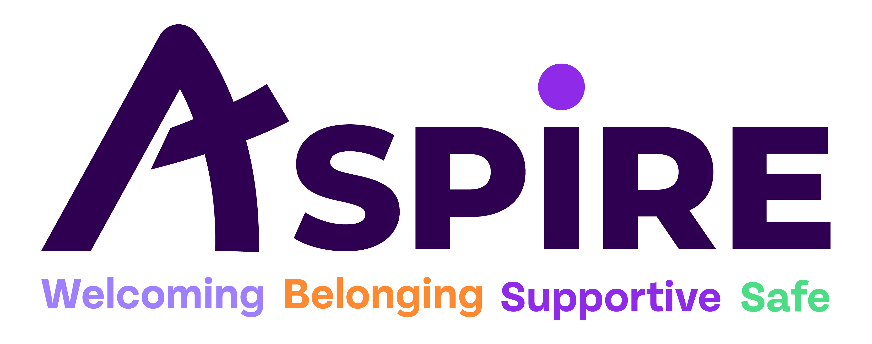
Creative and Young Peoples Services Co-ordinator
Reference:

Closing Date: Friday 27th June 2025
Thank you for your interest in the above post, please find the specific role requirements and duties for this post detailed within this document. When completing the application form you may submit additional documentation, however we cannot accept a CV as a completed application.
Please note the following:
Once you have submitted or posted your application form allow 10 working days after the closing date for a response. As we do not notify applicants of an unsuccessful application, if no response has been received within this time, please accept this as confirmation that your application has been unsuccessful. Previously unsuccessful candidates cannot reapply to Aspire Ryde within six months of their previous application.
Please return the completed application form by email to: nisha@aspireryde.org.uk or by post / by hand to Aspire Ryde, 24 Newport Street, Ryde, Isle of Wight, PO33 2QD.

Yours Faithfully

Trevor Nicholas
Chief Executive
JOB DESCRIPTION – Creative and Young Peoples Services Co-ordinator
Accountable to: Chief Operation Officer
The Role:
Aspire Ryde is seeking a dynamic and passionate individual to take on the newly created role of Creative and Young Peoples Services Co-ordinator, overseeing our Creative hub and all services and initiatives for young people aged 11–25. This post will play a key leadership role in coordinating and expanding our existing Creative and youth provision, including the Creative Hub, Aspire 2 be Active, Young Persons Mental Health and Money Advice, and developing new opportunities both on-site and in new locations across the Isle of Wight. As an experienced music practitioner, they will also lead on the outworking of Aspires Charitable Object to ‘Advance the Christian Faith’ including taking a lead on Christian Events, activities and Festivals, leading worship at Aspire meetings and working alongside Aspire Chaplaincy.

To note: This post will be offered as a one-year fixed term contract to begin, with an expectation that it becomes permanent when additional longer-term funding is secured. Should this not be the case, the post may be reduced to three days per week at the end of the first year.
In accordance with Schedule 9 of the Equality Act 2010, there is a Genuine Occupational Requirement for the successful candidate to be a committed Christian, as you will be expected to lead prayer and worship with individuals and groups as part of your role.

Main Duties
- Lead and coordinate all youth-focused programmes across Aspire Ryde, ensuring they are inclusive, safe, and high-impact.
- Oversee the day-to-day operations and development of the Creative Hub, supporting its use as a youth-led space for music, arts, and creative expression.
- Expand Aspire’s youth offer to other areas of the island, working with local partners, schools, and community groups.
- Develop our Children and Youth offer in Shanklin, Wootton, Cowes and other areas where we may be commissioned to deliver work on behalf of IW Council.
- Develop and manage the Aspire 2 be Active programme and the Young Persons Mental Health and Money Advice service.
- Work with others to develop and co-ordinate Christian events and activities within Aspire.
- Support the creation of a Youth Council, ensuring young voices help shape Aspire’s direction.
- Identify new funding opportunities and lead on income generation, including developing commercial use of creative spaces (e.g., music studio hire, event space).
- Line manage staff and volunteers involved in youth delivery, ensuring quality and safeguarding standards are met.
- Monitor impact, report outcomes, and contribute to long-term strategic planning for youth provision.
- safeguard service users from harm and work within the safeguarding policy.
- To provide written or verbal reports when requested.
- To accept support, supervision and guidance from senior colleagues.
- To identify training needs in discussion with colleagues and to attend training events and courses as required.
- Any other duties as identified by the Chief Operating Officer
PERSON SPECIFICATION – Creative and Young Peoples Services Co-ordinator
QUALITIES REQUIRED |  | Essential / Desirable |  | How Assessed
Experience of working with young people and leading youth related projects. |  | Essential |  | Interview
Experience of working within Music and the creative arts, leading projects and running events. |  | Essential |  | Interview
Ability to develop partnerships and spot opportunities for growth. |  | Essential |  | Interview
Passionate about empowering young people and making a difference in the community |  | Essential |  | Interview
Good written and verbal communication skills |  | Essential |  | Application & Interview
Committed and passionate Christian, in good standing within the Christian community |  | Essential |  | Application & Interview
Ability to work constructively and co-operatively as part of a consistent team approach |  | Essential |  | Application & Interview
Ability to work safely and responsibly without direct supervision within a community setting. Knowledge of Safeguarding. |  | Essential |  | Interview
Ability to demonstrate initiative, motivation and a resourceful, well organised approach |  | Essential |  | Application & Interview
Understanding of the person centred aims and principles of Aspire Ryde and ability to put these into practice |  | Essential |  | Interview
Ability to demonstrate respect for difference and diversity |  | Essential |  | Interview
Ability & experience to support and supervise volunteers. | Essential |  | Application & Interview
A good level of IT skills, and the ability to use MS Office programmes including Word, Publisher, Excel, Outlook | Desired |  | Application & Interview
Willingness to work flexible hours according to needs of organisation and service users | Essential |  | Application Form
Willingness to attend training courses and events | Essential |  | Application & Interview
Willing to accept feedback and guidance and to be accountable to colleagues and managers | Essential |  | Application Form
Ability to use and communicate via social media, emails, website and other electronic forms of communication | Essential |  | Interview
TERMS AND CONDITIONS – Creative and Young Peoples Services Co-ordinator
Pay:
£26,213 per annum.
Hours of Work:
35 hours per week.
Disclosure Checks:
Employment will be subject to enhanced Disclosure and Barring Service checks

