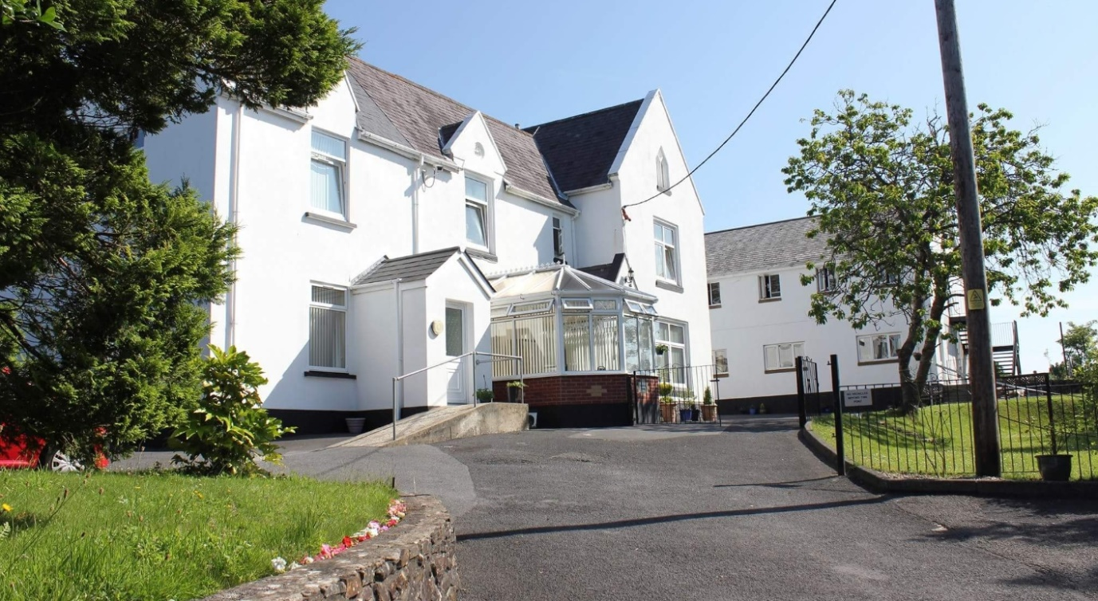

Job Vacancy at Teen Challenge
Hope House
Hope House is a successful Christian residential rehabilitation centre working with vulnerable women as they overcome substance misuse. We are looking for the right applicant who will work as part of our team providing practical support and care to the residents.

Vacancy Details:
Senior Support Worker
Hours: 40 per week, on a shift system, plus paid sleep over
Annual leave: 20 days pa (plus bank holidays in lieu)
Location: Hope House Women's Residential Centre 6, Church Road, Gorslas, Llanelli, SA14 7NF
Specification: Due to the nature of our work and the vulnerability of the residents this post is only open to female applicants. [Gender is considered to be a genuine occupational requirement in accordance with paragraph 1 of Schedule 9 of the Equality Act 2010]

Main Duties: To meet regularly with a designated group of residents providing advice and support; enabling and monitoring them as they develop plans to meet their goals to live independently from substance misuse; deliver prepared teaching materials to groups of residents and undertake a ‘duty officer’ role on specified shifts.

The successful applicant will provide a role model of personal effectiveness and encouragement to the residents as they undertake a life-changing programme. Salary details for the post will be made available on application.
Closing date for applicants 27/06/2022. For an application pack, including a full job description, please contact Alicia Ward on 01269 844114 or email alicia.ward@teenchallenge.org.uk
A Member Country of Global Teen Challenge, Registered UK Charity, No. 298900

