Epsom Methodist Church

Ministers:
Rev Catherine Hutton
Rev Ung Soon Nguang

Ashley Road, Epsom, Surrey KT18 5AQ
01372 728535

Registered Charity Number 1127787

Mission and Outreach Worker
APPLICATION PACK
Thank you for your interest in the Mission and Outreach Worker position at Epsom Methodist Church. Please find attached the Application Pack for this role.
To apply, please send:
- Your completed Application Form (see section 4 of this pack) and
- Your CV (including details of previous positions, training received and qualifications held)
to our Church Office, either by email (office@epsommethodistchurch.org.uk) or post (Epsom Methodist Church, Ashley Road, Epsom, Surrey, KT18 5AQ).
The closing date for applications is 15th June 2022.
Interviews will be held on 5th and 6th July at Epsom Methodist Church.
Job start date: September – December 2022

CONTENTS:

- Profile of Epsom Methodist Church
- Job Description
- Outline Terms and Conditions of the position + Ideal Qualifications of candidates.
- Application Form

- Ministries Audit report (PowerPoint presentation)

- PROFILE OF EPSOM METHODIST CHURCH

Epsom Methodist Church ‘EMC’ is very close to the Centre of Epsom town (about 100m from the High Street) and so is very conveniently situated for events involving the Epsom Community.

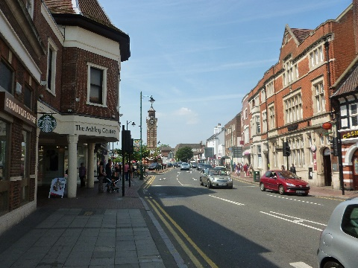

EMC is a large Methodist Church with four services every Sunday (combined attendance 250-300):
9am: Traditional service
10.30am: More contemporary service including children’s and youth work
2pm: Chinese Service (CCEMC) and International Congregation service

EMC, like many other Churches, is emerging from the restraints of the recent pandemic and is seeing a return to pre-pandemic attendances at Sunday services. All services continue to be offered as both live and ‘streamed’. However, the most significant development has been in the number of people coming through our doors during the week for a variety of church and community run activities, particularly our children’s events. There are several other signs of renewal and encouragement that are challenging us to new work. It was as EMC was emerging from the pandemic in late 2021 that the Church Council commissioned a group of Church Members (the Ministerial Audit group) to review the staffing requirements for EMC going forward for the next 5 years. The conclusions of that group were that EMC should be recruiting staff to drive our Mission and Outreach, our pastoral care, our worship leading and our Children’s ministry. This appointment is part of that recruitment. More details of that report are attached as a PowerPoint presentation.
A more concise and informative profile of EMC is available from the website www.epsommethodistchurch.org.uk but briefly:
Ministry Team: The current Ministers are the Rev Catherine Hutton and Rev Ung Soon Nguang (responsible for the Chinese Church)
Pastoral Work: There is an active Pastoral Committee/Group which meets every Monday morning to discuss visiting and supporting our members.
Uniformed Groups: the Uniformed Groups associated with EMC are amongst some of the most active in the UK, including Beavers, Rainbows, Cubs, Brownies, Scouts, Guides, Explorer Scouts and Rangers. We are working to establish closer links with these groups.
Coffee Shop: A Coffee Shop “Roots” was opened on our premises in April 2017 and has proved very successful both in providing opportunity for outreach and mission as well as financially.

Music: We have a flourishing music group that provides music at our Sunday 10.30 service. There is a team of volunteer musicians who play at services and at children’s activity days.
House and other Groups: There are five active house groups, and we are looking to start new groups. These groups continued via ‘Zoom’ during lockdowns and have continued to meet more regularly this way. There are several other groups and activities which we are seeking to develop further.
Welcome Club: - Each month this welcome, friendship, sharing and drop in club is an event for all
Elderly People: For the last five years during August EMC has run ‘Holiday at Home’ attended by older members of EMC and the local community. The Church provides Christmas lunch for about 60 guests, and other groups meet regularly.
Book Fair: Each February half-term EMC runs the largest Charity Book Fair in England and Wales which raised over £41,000 for charity in 2019. It involves about 200 helpers from the Church and local Charities and is visited by over 3,000 people.
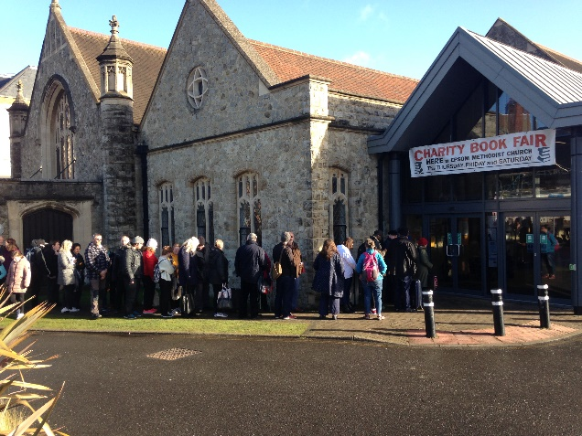

Outreach: We seek opportunities for outreach, for example we have recently, with the Chinese Church, operated Christmas and Easter market stalls to attract the local community with activities such as face painting, children’s choir etc. The Mission and Outreach Worker would be expected to be a key member of such outreach. We have also been a lead player in the ‘Hope into Action’ project in Epsom that has funded and provided accommodation for homeless people.
Finances: EMC is financially well endowed, particularly following a recent, very generous legacy. The Stewards are looking to spend a material part of this legacy on increasing our Mission and Outreach.
Web site: http://www.epsommethodistchurch.org.uk is managed in-house and is an online resource, showcasing many church activities, run in parallel with paper-based communications such as Weekly Notes.
Staff: The office is managed part time by Sarah Meech who oversees the lettings and the property as well as oversight of many other aspects of running our Church. There is an assistant who provides support across a range of activities including updating the website. The Church lets out its rooms to more than 30 different local groups and derives significant income from this activity. We are looking to promote events at the Church more actively to these groups.

Children and Families work

Our current activities include:
- Junior Church every Sunday where attendance has fallen recently and we need to appeal more to families which we are addressing through several initiatives.
- A monthly Messy Church which has about 60-90 attendees.
- Holiday Clubs (one week in summer holiday with about 50 children last year, as well as BBQ/Picnics etc.
- Our Christmas events for children and families include an under-5s Nativity Praise service and a Christingle service.

- JOB DESCRIPTION

Role: Mission and Outreach Worker at Epsom Methodist Church

The final job description will be agreed with the appointed person and will depend on their particular strengths and special interests

- Summary of Purpose
To work with the ministerial team and members at EMC to develop and deliver Mission and Outreach initiatives

- Main Duties will include:
- Develop a strategy for mission with short and long-term goals. Be able to speak about faith in non-church language.
- Facilitate and develop streams of consistent missional events/outreach programmes at and in EMC’s name, having an eye to different stages of faith journey and encouraging a pattern of next-step engagement.
- Enthuse and equip a pool of volunteers and other team members to be supportive of the agreed vision and to 'be church around the new’.
- Equip and support Housegroups in following the church’s curriculum, support the creation of new groups and identify and train new leaders and hosts.
- To equip people for faith through teaching and preaching and being able to be creative with approaches to sharing the good news (including Sundays)
- Engaging with what is happening elsewhere and allowing it to feed and support local ministry and sharing training in mission with the wider Circuit.

- OUTLINE TERMS AND CONDITIONS
- Terms of appointment: This is an initial 5 year appointment.
- The salary will be £ 28-33k per annum.
- Normal working pattern: 40 hours per week.
- Opportunities for study and for training.
- All reasonable expenses will be reimbursed. This will be with agreement of the line manager.
- Suitable housing will be provided
- Pension – 6% contribution from EMC, 6% paid by employee
- At least one day free of responsibilities each week.
- Holiday entitlement: 28 days (including bank holidays)
- Appointment will be subject to a satisfactory Enhanced Disclosure & Barring Service (DBS) disclosure.
- Appointment will be subject to satisfactory references.
- Appointment will be subject to the satisfactory completion of a six-month probationary period. If necessary, EMC reserves the right to extend the probationary period.
- Applicants must be a U.K. resident or hold a Tier 2 permit to work.

IDEAL QUALIFICATIONS:
We are eager to see lives changed through the power of Christ’s love both in our congregations and the wider community. It is our expectation that the candidates will have: -
- A recognised Biblical, theological, or practical mission qualification
- Be a current and active member of Christian Church or community
- some practical evangelism or outreach experience
- An ability to lead worship
- Be I.T. literate and the ability to engage with the role social media plays in people’s lives
- An ability to communicate effectively both written and oral
- An ability to represent a strong Christian example
It would also be desirable for candidates to have: -
- Educated to GCSE level or equivalent
- A proven ability of being flexible and adaptable to changing needs and requirements
- The ability to motivate self and others
- The ability to contribute to a team
- The ability to train church members and equipment people to share their faith.

You will be required to demonstrate that you are either a UK national or have a permit to work in the UK and to provide evidence of already having DBS certification.

- APPLICATION FORM: Mission and Outreach Worker
Name: …………………………………………………………………………………………………………
Address: ……………………………………………………………………………………………………….
Postcode: ……………………………………………………….
Email: ………………………………………………………..

Tel No: ………………………………..

Given the above profile of EMC how would you go about developing our Christian mission and outreach within EMC and into the wider community of Epsom and Ewell (including the use of social media, or contacts with schools, church users, community etc)?

Please describe how you currently exercise your work with Mission and Outreach and your particular skills, distinctive gifts and strengths:

What do you, personally, want to achieve during this appointment?

Please describe briefly why we should choose you for this position:

Other interests or information related to this position you wish us to consider:

DATE: ……………………………………………….
Please also attach a copy of your CV.

