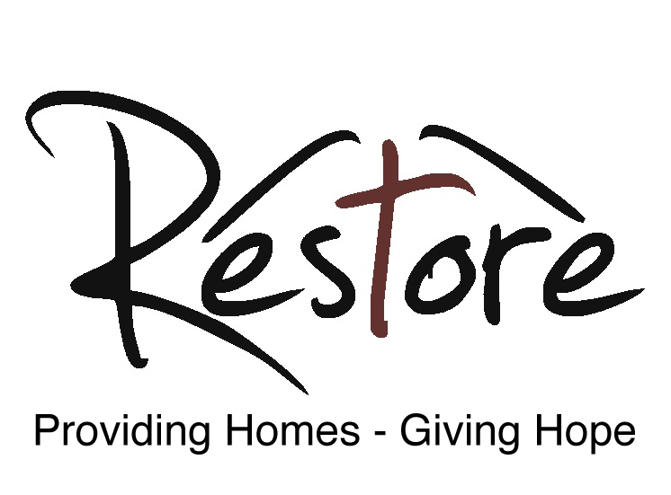

Housing Support Worker

Job Description

Job Title: Housing Support Worker

Reports to: Senior Housing Manager

Salary: £19,000-£22,000

Hours: 35 hours per week (1.0 FTE)

Benefits: 26 days annual leave entitlement plus statutory Bank Holidays, employer contribution pension. Hybrid office / home working options.

Our vision:
Our vision is for a York where everybody has a home, where those who have been homeless before are rebuilding their lives, and where the city works together to beat the underlying causes of homelessness.

Our mission:
We provide a loving space where lives can be restored. Everyone deserves a place they can call home, but society’s injustices can put unbearable financial and personal pressure on some people. Where that gets too much, and people have become homeless, Restore relieves the pressure. We provide safe and stable homes, one-to-one mentoring, love, mental health support, social activities and the offer of Christian support and prayer. Through our work, we also show that by easing the pressure that leads to homelessness, we can create a better society for all of us, freeing more people to achieve their full potential.

As part of this mission Restore seeks to employ a Housing Support Worker to join our existing team of staff providing support to our residents. Full time Housing Support Workers will work with a caseload of around 10 residents and will typically have responsibility for the property management of two to three houses of multiple occupancy.

Key areas of responsibility:
Support | Help conduct interviews for prospective residents
 | Completing induction paperwork with new residents such as risk assessments and needs assessments
 | Completing support plan paperwork and writing an action plan of how to support a resident during their time at Restore
 | Assisting the resident in progressing through their action plans by providing support or referring to agencies who can provide more specialist support
 | Attending appointments with residents as well as assisting them in completion of paperwork and phone calls
 | Assessing need, and providing support necessary to aid the physical, emotional, mental, social and spiritual wellbeing of residents
 | Assisting residents with their benefits claims to ensure that they are receiving the money to which they are entitled
 | Attending social events run by Restore for its residents
 | Manage spending of engagement fund to allocated budget
Properties | Conduct visits to properties to check on the safety and security of the property.
 | Collecting top up and rent from residents
 | Reporting maintenance issues when required
Rotas | Assisting with on call procedures throughout evenings and weekends on a rota basis.
 | Attending the weekly staff team meeting and morning prayers.
 | Leading staff devotions as part of the rota
Policies and Procedures | Ensure that service delivery is in line with local policies and procedures and legislative framework
Faith | Commitment to pray regularly for Restore and its residents
Office | Ensure accurate, timely and secure storage of paperwork and electronic files in the office

Person Specification
Working with vulnerable people can often mean confronting anti-social and challenging behaviour. Issues such as substance misuse, addictions, poor mental health, anger, anxiety and depression are often prevalent within the client group with whom we work. Whilst adequate training can be offered, it is essential that the candidate possesses excellent interpersonal skills (such as assertiveness, communication, resilience and compassion) in order to deal with people who are exhibiting challenging behaviour. It is also essential that the candidate has some level of experience in dealing with people who may present with such issues. In addition to being able to work with people demonstrating challenging behaviour it is also essential that the candidate has strong admin skills as well as being conversant with IT programmes such as Microsoft Office, Email, Webforms, etc.
Essential
• Experience working with vulnerable adults
• Ability to show compassion to people in need
• Ability to understand the needs of the client group
• Ability to manage your time and workload independently and effectively
• Working knowledge of issues around substance misuse and mental health problems
• Resilience and assertiveness when confronting challenging behaviour
• Good written and verbal communication skills

Desirable
• Two years of experience working in the housing sector.
• Knowledge of the current framework regarding Universal Credit, Housing Benefit, and other benefits.
Due to the strong Christian ethos which underpins the values of Restore (see below) and its service delivery there is a genuine occupational requirement for the postholder to be a practising Christian.
Training
It is recognised that most applicants will not have extensive knowledge and experience of all aspects of the role. Restore will provide access to training which it deems is required in order to equip the successful candidate with the skills to perform the role well.

Our values:
“…This is the kind of fasting I want: Free those who are imprisoned; lighten the burden of those who work for you. Let the oppressed go free, and remove the chains that bind people. Share your food with the hungry, and give shelter to the homeless. Give clothes to those who need them, and do not hide from relatives who need your help…. Some of you will rebuild the deserted ruins of your cities. Then you will be known as a rebuilder of walls and a restorer of homes.”

Restore is an anti-poverty charity that works with people of any faith or none. We are grounded in Christianity, particularly in scriptural calls to engage in social action and to pursue justice. Restore’s founders were inspired in particular by Isaiah 58, a rallying call to us all to get out of our comfort zones, conversations and huddles and to instead take action to help those in need and to oppose injustice.

Suppose you see a brother or sister who has no food or clothing, and you say. “Goodbye and have a good day; stay warm and eat well” – but then you don’t give that person any food or clothing. What good does that do?”

We work with other statutory and charitable organisations in and around York, to provide homes for people who would otherwise be homeless, and to identify and address the underlying causes of homelessness. We love our residents and we stand shoulder to shoulder with them as they rebuild their lives.

“Speak up for those who cannot speak for themselves, ensure justice for those being crushed. Yes, speak up for the poor and helpless, and see that they get justice.”

We are loving. We love our residents and want what is best for them. Their welfare is paramount to us. We comfort them in hard times and rejoice with them in their progress.

We are Christian. Our trustees are Christian and much of our support comes through local churches. We pray for our residents and for wisdom in our decisions.

We are enabling. We are a stepping stone for people on their way to a better life, supporting them as they build a new home and new hopes.

We are vocal. We speak up for our residents and for people who are homeless. It is simply not right that society tolerates homelessness and denies justice and dignity to our fellow citizens. We speak truth to power and call out injustice when we encounter it.

We are confident. We know homelessness can be ended. We believe York can help lead the way.

